Freefall Motion

w/ Pasco Discover Freefall System

Equipment

Dell Laptop Computer
AC Adapter, Dell Laptop
Discover Free Fall System Pasco Sci. ME-9889
Discover Free Fall Accessory Pasco Sci. ME-9893
Adapter (2), Vernier DG-BTD
Multi-Clamp, Pasco Scientific ME-9507
Ring Stand, 135 cm w/ meter stick
LabQuest Mini, Vernier LQ-MINI
Mini USB Cable, Vernier CB-USB-MINI

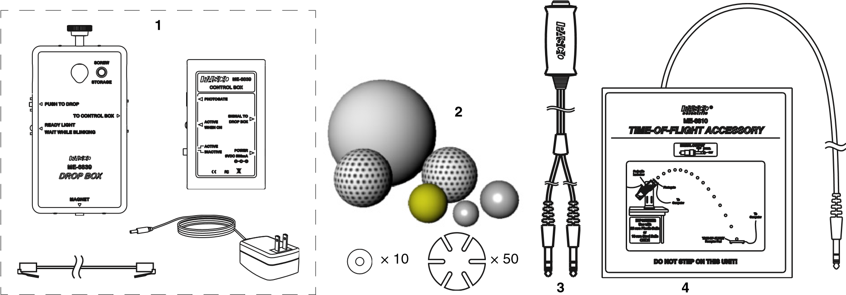

Typical Setup
Figure 1
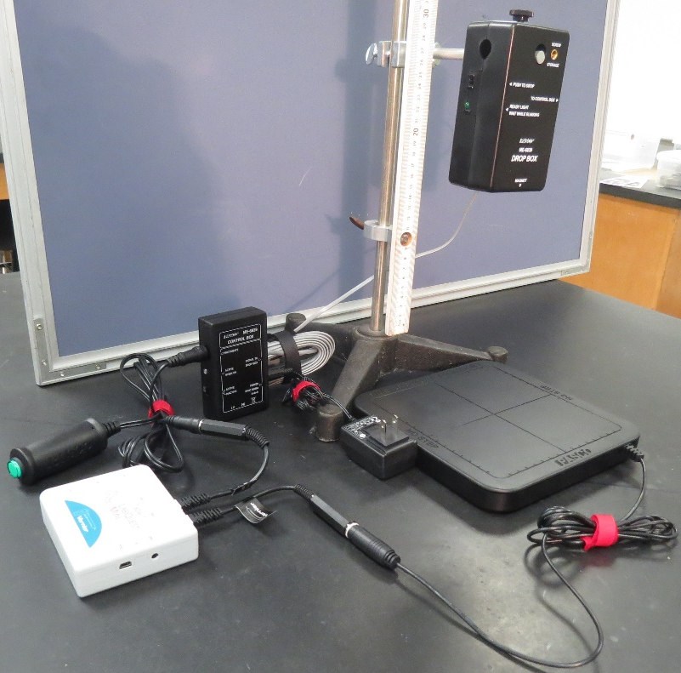
Wiring Diagram
Figure 2
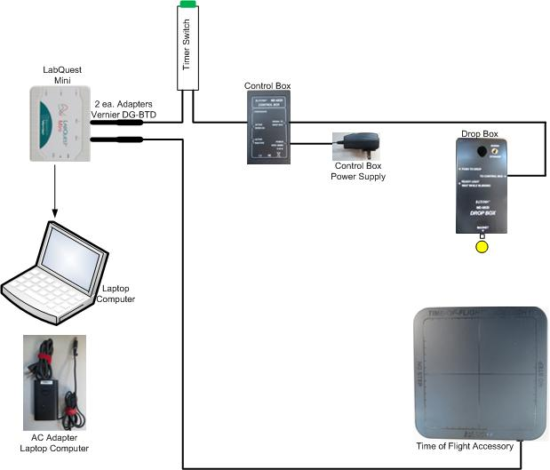

Physical Detail
Figure 3
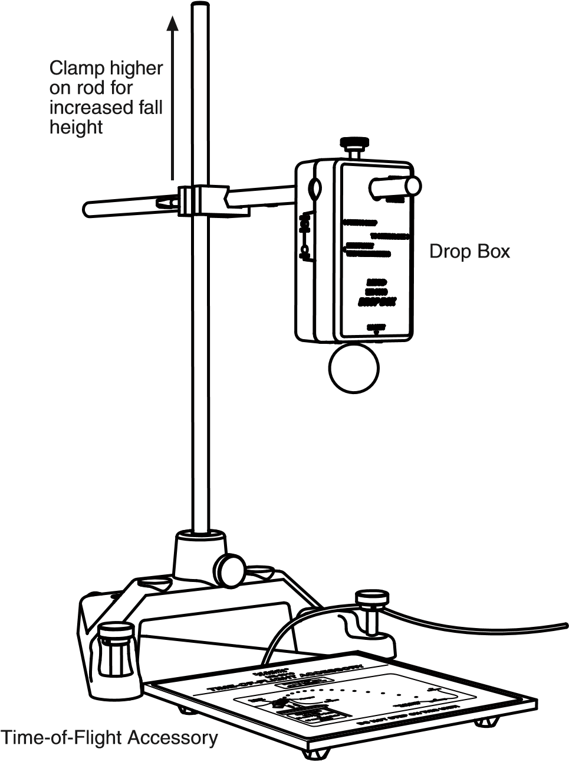

Terminology
- kinematic equation: an equation that relates two or more kinematic variables, such as displacement, time, velocity, acceleration.
- g: the acceleration of a falling object due to gravity near the Earth, in the absence of air friction effects. Usually taken as .

Overview
You will measure the time it takes for a steel ball to fall from various heights.
Introduction
An object dropped near the Earth’s surface will fall with an acceleration of g, independent of its mass. This was the famous observation of Galileo. This is true specifically when air friction effects are negligible. Thus in a vacuum, a feather falls as quickly as a gold ring. The kinematic equation which describes the vertical position of an object at any time if it is dropped from rest is
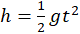 Equation 1
where is the height above the contact plate from which the steel ball falls.
Remembering the general formulation for a straight line
Equation 2
we can relate equations 1 and 2 to a straight line by identifying
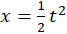
Thus:
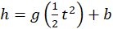 Equation 3
Experimentally determine the parameters m and b in Equation 3. This is accomplished by measuring h and t for various heights of fall for a steel ball. After the data has been acquired will plot y vs. x, where x and y take on the values shown in Equation 3. The slope of your best-fit line will be your value of g, and the intercept will be a further check on the validity of Equation 3.

Accuracy
- Both of your observations, time, and distance, should be recorded to
3 significant figures. You should carry 3 significant figures in all of your calculations as well.

Procedure
- Set up the ball release mechanism on a vertical stand that will allow various heights h to be arranged for the mechanism.
- Place the steel ball in the mechanism and hold it in place by pressing directly on the spring-loaded plunger rather than on the ball (otherwise the mechanism will not hold the ball securely). Set the tightening screw so that the ball is held in place.
- Place the stop timer plate directly underneath the ball.
- Measure the height h as shown in Figure 3: from the bottom of the steel ball.
- Reset the timer. Release the ball. Record h and t for the fall.
- Repeat at different heights for a total of six data points.

Figure 3
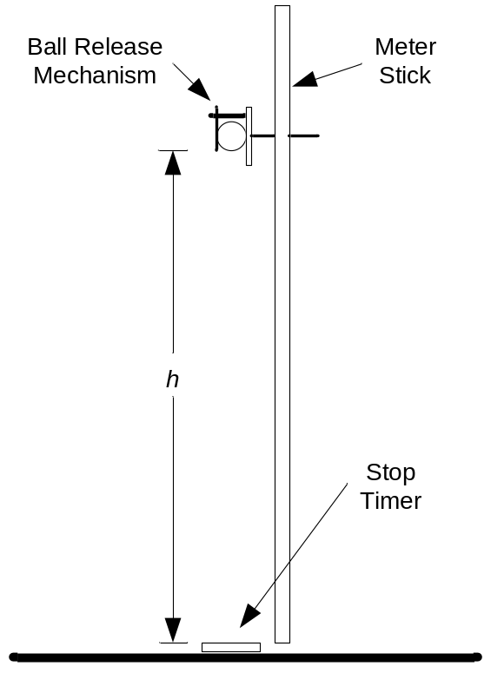

Data
Trial | height  (m) | elapsed time  (s) | 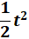  ()
1
2
3
4
5
6

Analysis
Using Microsoft Excel® make a scatter plot of your measured values of height, h, versus one-half elapsed time squared, . Include a best-fit line and the equation w/ slope, for example:

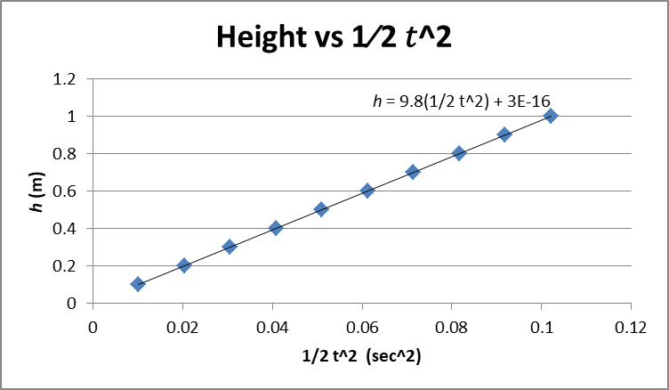

The slope of your best-fit line will be your value for “g”. Write to 3 sig. fig.
Report
I. Procedure. Note any differences in your actual procedure from that stated in this handout. Explain why you made these changes and to what end result (better or worse). Note any difficulties you had in performing the experiment. If you performed the experiment with no changes whatsoever, then so state this fact.
II. Data. Present your data in a neat and organized manner. Legibility counts. Use units where necessary.
III. Analysis. Clearly outline any calculations you made showing your numbers and units. Include your graphs following the correct graphing procedures. Label fully and show on the graph any analyses you are making from the graph.
IV. Questions. Clearly answer any questions posed.

Questions
- What is your value for g? ________________(three sig. fig.)
- What is the percent difference of your value from 9.80 m/s²?
_________________________________________________________________
- Is your value of g reasonable? Explain why or why not.
- What is the value of the intercept on your graph (3 sig. fig.) ______________? If this number is not exactly zero, what is its meaning?

